

Part - 1 : Word Occurrence Counting using Pthreads

Student Id : 2407710
Student Name : Dhadkan K.C.
Group : L6CG4
Lecturer : Mr.Yamu Poudel

Table of Contents
Overview 1
How to Compile and Run 1
Compile 1
Run 1
Explanation (Detailed) of the Solution 2
Word Definition (Token Rule) 2
Multithreading Approach 2
Dynamic Slicing (Load Balancing) 2
Synchronization (Thread Safety) 3
Chunk Assignment Mutex 3
Global Merge Mutex 3
Avoiding Part Words at Slice Boundaries 3
Sorting and Writing Output 4
Results and Screenshot 4
Limitations and Notes 6
Source Code 6
Code Structure Overview 10
The modules of the source program are: 10
Techniques of Synchronisation in Code. 10

Overview
In this assignment, a word occurrence counter application is executed in a multithreaded fashion, with the POSIX threads (Pthreads) library. The primary goal is to enhance the performance through sharing the workload among multiple threads and ensuring that there is accuracy through proper synchronization.
The program accepts a text file given to it through the command line, processes the contents of this file in parallel and counts the frequency of words. Dynamic slicing is employed in order to have the workload distributed in balance, whereby threads can reclaim new chunks of work over and over again instead of being bound to a fixed slice. The frequency of words obtained after processing is combined, sorted alphabetically, and put to an output file.

How to Compile and Run

Compile
gcc -pthread task1_wordcount_pthreads.c -o wordcount

Run
./wordcount <inputfile.txt> <threads>
Example
./wordcount WordOccurrenceDataset.txt 8

- <threads> specifies the number of Pthreads to create and must be greater than zero.
- If [output file] is not provided, the program writes the result to result.txt by default.
Input/Output Files
- File name: WordOccurrenceDataset.txt
- parallel
- university
- compilation
- algorithm

- Type: Plain text file
- Description:
The file contains readable text data and is not a binary format such as .doc or .docx.
Output File
- File name: result.txt
- Each line follows the format:
- student : 2456
- teacher : 2413
- linkedlist : 1328
- synchronisation : 1323

Explanation (Detailed) of the Solution

Word Definition (Token Rule)
A word is described as a continuous alphanumeric conjunction which contains:
- Letters (A–Z, a–z)
- Digits (0–9)
Any character that is not alphanumeric including space, punctuation marks, breaks, or symbols are all considered separators. Words are then turned into lowercase and then counted to allow different variations of the word i.e. Word, word, and WORD to be treated as the same.

Multithreading Approach
All the input file is initially loaded into internal memory buffer. All the threads are made to treat this buffer as read only in order to prevent data races. The threads work on various parts of the buffer, extract words and keep local word-frequency-list.
Locking operations are greatly minimized using local data structures in processing. After the completion of the task allocated to each thread the local word counts in each thread are added to a global data structure in a coordinated and synchronized fashion.

Dynamic Slicing (Load Balancing)
The program applies dynamic slicing rather than the static partitioning to prevent the skewed distribution of workload. A common index is used to monitor the following unprocessed part of the file.
Each thread repeatedly:
- Locks the shared index mutex
- Reserved the following available chunk [start, end)
- Updates the shared index
- Unlocks the mutex
- Processes the claimed chunk
With this strategy, the faster threads will automatically process more chunks and this will result in better load balancing and increased CPU utilization.

Synchronization (Thread Safety)
The synchronization (Thread Safety) of a programming language can be described as a programming language featuring a mechanism by which multiple threads of execution can execute a program safely and without interference.
A programming language can be said to have a synchronization (Thread Safety) feature whereby several threads of execution can execute a program safely and without interference. The thread safety is determined by two mutextes:

Chunk Assignment Mutex
This mutex guards shared chunk pointer in order to ensure that two threads do not access the same part of the file.

Global Merge Mutex
This mutex will keep the global word list in a state of exclusive access throughout the merge phase to avoid being raced out when updating word frequencies.
Combining these mechanisms ensures that there is no needless contention as far as parallel execution is concerned.

Avoiding Part Words at Slice Boundaries
In a situation whereby the text is split by the byte ranges, a slice can start or end in the middle of a word resulting in the wrong token rather than the actual execution.
To prevent this issue:
- The slice start index is shifted forward in case it is in a word.
- The slice end index is continued until a word which has not been completely cut is fully covered.
This methodology makes sure that the process of tokenization is guided by the rules of word definition and does not produce invalid words.

Sorting and Writing Output
When all threads are finished processing and merging:
- World list is sorted in alphabetical order.
- The frequency and each word are outputted to a file in a line-after-line manner.
The outcome of this final step is a clean and structured and easy to read result file.

Results and Screenshot
Input file : WordOccurrenceDataset.txt
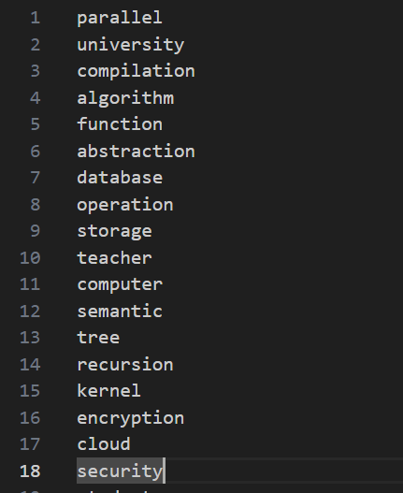

Compilation:

Run:

Output file: result.txt
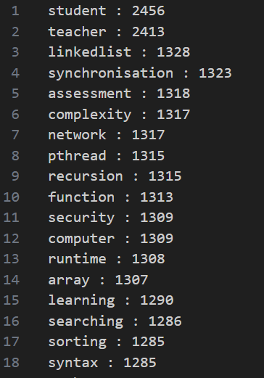

Limitations and Notes
- Large matrices significantly increase memory usage and execution time, particularly for matrix multiplication.
- Floating-point arithmetic may introduce rounding errors, especially when working with large values or repeated operations.
- The program assumes correctly formatted input files; malformed matrix definitions may cause unexpected behavior.
- Sparse matrices are not supported and are treated as dense matrices, leading to inefficient memory usage.
- OpenMP parallelization is limited to shared-memory systems and does not scale across distributed systems.
- Overhead from thread creation and synchronisation may outweigh performance benefits for very small matrices.
- Cache efficiency may degrade for very large matrices due to non-optimal memory access patterns.

Source Code
#include <stdio.h>
#include <stdlib.h>
#include <string.h>
#include <pthread.h>
#include <ctype.h>

#define WORD_LEN 50
#define MAX_WORDS 10000

char **lines;
int total_lines = 0;
int current_line = 0;

char words[MAX_WORDS][WORD_LEN];
int counts[MAX_WORDS];
int total_words = 0;

pthread_mutex_t line_mutex;
pthread_mutex_t word_mutex;

void add_word(char *word)
{
pthread_mutex_lock(&word_mutex);

for (int i = 0; i < total_words; i++) {
if (strcmp(words[i], word) == 0) {
counts[i]++;
pthread_mutex_unlock(&word_mutex);
return;
}
}

strcpy(words[total_words], word);
counts[total_words] = 1;
total_words++;

pthread_mutex_unlock(&word_mutex);
}

void *count_words(void *arg)
{
while (1) {
pthread_mutex_lock(&line_mutex);
int line_number = current_line++;
pthread_mutex_unlock(&line_mutex);

if (line_number >= total_lines)
break;

char *line = lines[line_number];
char word[WORD_LEN];
int idx = 0;

for (int i = 0; line[i]; i++) {
if (isalpha(line[i])) {
word[idx++] = tolower(line[i]);
} else if (idx > 0) {
word[idx] = '\0';
add_word(word);
idx = 0;
}
}

if (idx > 0) {
word[idx] = '\0';
add_word(word);
}
}
return NULL;
}

void sort_by_frequency()
{
for (int i = 0; i < total_words - 1; i++) {
for (int j = i + 1; j < total_words; j++) {
if (counts[j] > counts[i]) {
int tmp_count = counts[i];
counts[i] = counts[j];
counts[j] = tmp_count;

char tmp_word[WORD_LEN];
strcpy(tmp_word, words[i]);
strcpy(words[i], words[j]);
strcpy(words[j], tmp_word);
}
}
}
}

int main(int argc, char *argv[])
{
if (argc != 3) {
printf("Usage: %s <file> <threads>\n", argv[0]);
return 1;
}

FILE *fp = fopen(argv[1], "r");
if (!fp) {
printf("Cannot open file\n");
return 1;
}

int num_threads = atoi(argv[2]);
pthread_t threads[num_threads];

printf("Word count program starting...\n");
printf("Input file: %s\n", argv[1]);
printf("Number of threads: %d\n", num_threads);
printf("Output file: result.txt\n\n");

pthread_mutex_init(&line_mutex, NULL);
pthread_mutex_init(&word_mutex, NULL);

int capacity = 100;
lines = malloc(capacity * sizeof(char *));
char buffer[256];

while (fgets(buffer, sizeof(buffer), fp)) {
if (total_lines == capacity) {
capacity *= 2;
lines = realloc(lines, capacity * sizeof(char *));
}
lines[total_lines] = strdup(buffer);
total_lines++;
}

fclose(fp);

printf("Total lines read: %d\n", total_lines);
printf("Starting word counting...\n");

for (int i = 0; i < num_threads; i++)
pthread_create(&threads[i], NULL, count_words, NULL);

for (int i = 0; i < num_threads; i++)
pthread_join(threads[i], NULL);

printf("Word counting finished\n");
printf("Sorting results...\n");

sort_by_frequency();

FILE *out = fopen("result.txt", "w");
for (int i = 0; i < total_words; i++)
fprintf(out, "%s : %d\n", words[i], counts[i]);
fclose(out);

printf("Processing completed\n");
printf("Total unique words: %d\n", total_words);
printf("Results written to result.txt\n");

return 0;
}

Code Structure Overview

The modules of the source program are:
Header inclusions, configuration macros Since this is a programming language, the program includes some standard libraries ( stdio.h, stdlib.h, pthread.h, ctype.h, and so on ) and defines some constants like capping the word length and chunk size.
International common data structures: They share input file via a common buffer, words list, frequency and mutex are common and counted as variables used to achieve mutex.
Thread worker routine: This is each Pthread whose routine makes dynamic claims over the input buffer, tokenises the words and maintains a list of word-frequency worships per-thread.
Word processing utility: Auxiliary functions do tokenisation of the input text, normalise words to lowercase and modify local counters respectively.
Merge routine: This routine uses mutex to ensure the safety of shared data as well as concatenating all threads of the count of local words each word into the global list.
Main routine: The main routine will read the command-line arguments, the input file, and create threads, which are then synchronised with pthread-join and the resulting data is ordered and the output is then written to a file.

Techniques of Synchronisation in Code.
A mutex used to assign chunks is used to ensure that each thread gets different slice of the input buffer.
The racial condition is avoided when each word is fed into the global word list using a separate merge mutex.

